**Private schools in Frankfurt and cost of study(Business Informatics/ Data analysis)**

**Studium/ Frankfurt schoo**l

Institution; <https://www.frankfurt-school.de/home/programmes>

Course of study; <https://www.frankfurt-school.de/home/programmes/master/data-analytics-management>

Cost; EUR 35,500 (for 4 semesters)

Early Bird Discount (EUR 3,500): 31 May 2024

Pre- experience masters fee;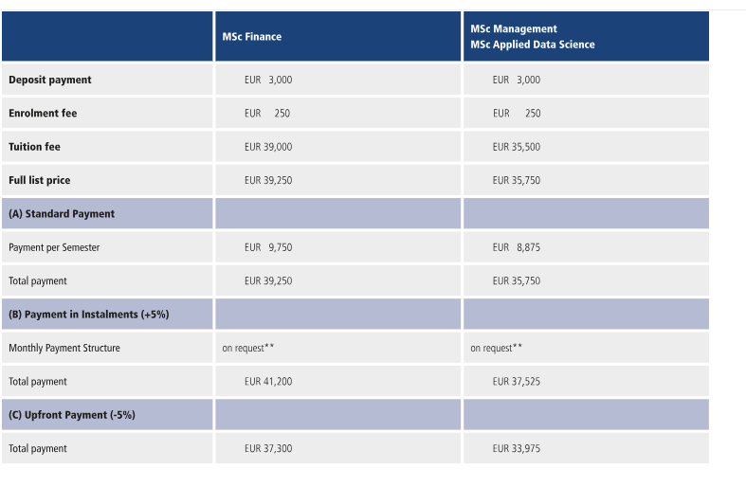

Post- experience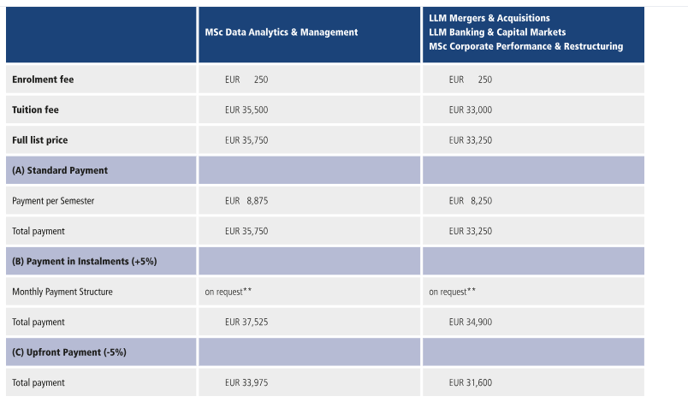

<https://www.frankfurt-school.de/en/home/programmes/master/New-financing-option>?

**FOM University**

<https://www.fom.de/de/studienberatung/faq/zulassungsvoraussetzungen.html?gad_source=1&gclid=Cj0KCQjww5u2BhDeARIsALBuLnMvgY9FY7jEOQgzfNvJJgQOXVRA3ESaI8ExrrUV7KB1q97NJRzzex0aAjwXEALw_wcB>

Course; AI and Business analysis

Cost; EUR13,950

For more information:

<https://www.fom.de/content/fom/master-big-data-und-business-analytics.html>

**iu INTERNATIONALE HOCHSCHULE**

<https://www.iu-mystudium.de/master/wirtschaftsinformatik/>

For more on information on business informatics: <https://www.iu-mystudium.de/master/wirtschaftsinformatik/>

Cost: <https://click.info.iu.org/?qs=db329f09e6c24fc37d188846bc384446994a6f797b594fa55c3b89e2a36b6bce3ea0f8133b7c9b6bb0bb77e579850d7270201d44c5dc22471e09ceaf5401858b>

The above link gives more clarification on cost and brochure

**Data analytics institute**

Cost : free

Link below will give you more insite

<https://data-science-institute.de/data-analyst/?js_source=google&js_medium=cpc&js_content=&js_term=&js_campaign=search_weiterbildung#>

**ISM University of applied science:**

<https://en.ism.de/full-degree-students/master-programs/master-business-intelligence/overview>

Cost: **Per semester:**

* 5,700 Euro (for contracts signed for fall term 2024)
* 6,480 Euro (for contracts signed from spring term 2025 onwards)
* Monthly payments are also possible. Please ask your study advisor for more information.
* **Enrollment fee**
* EU- & EWR-students: 600 Euro

**Frankfurt University of Applied Sciences**: Frank<https://www.frankfurt-university.de/en/studies/application-and-enrollment/master-programs/furt>

**Course : Business information**

Cost information and other enquiries: <https://www.frankfurt-university.de/en/studies/master-programs/business-information-systems-msc/for-prospective-students/#:~:text=Inquiries,69%201533%2D2400>

**Wilhelm Buchner Hochschule**

<https://www.wb-fernstudium.de/>

**Tuition fee:** Study from just €369 per month.

More info on tuition:<https://www.wb-fernstudium.de/kursseite/master-studiengang-wirtschaftsinformatik-msc.html>